The Structure, Properties and Uses of Diamond

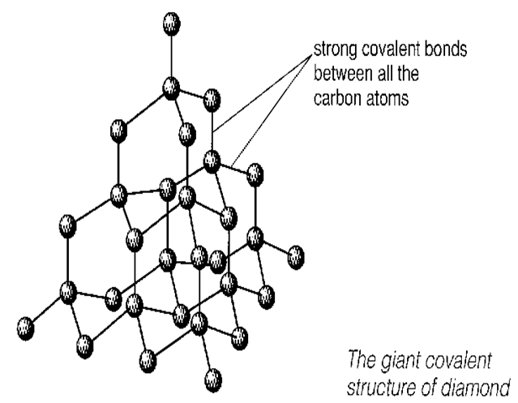 | Description of diamond  eg. How many bonds does each C have?  What kind of bonds?  Describe the shape of the structure.  _____________________________  _____________________________  _____________________________  _____________________________  _____________________________  _____________________________

Properties | Reason for this property
Melting point:

Hardness:

Electrical conductivity:

Uses | Reason for this use
Cutting tool

